**LAB 6:**

**Ethernet and ARP v8.0**

**Name: Hồ Đức Trí**

**Student No: 1912288**

1. What is the 48-bit Ethernet address of your computer?

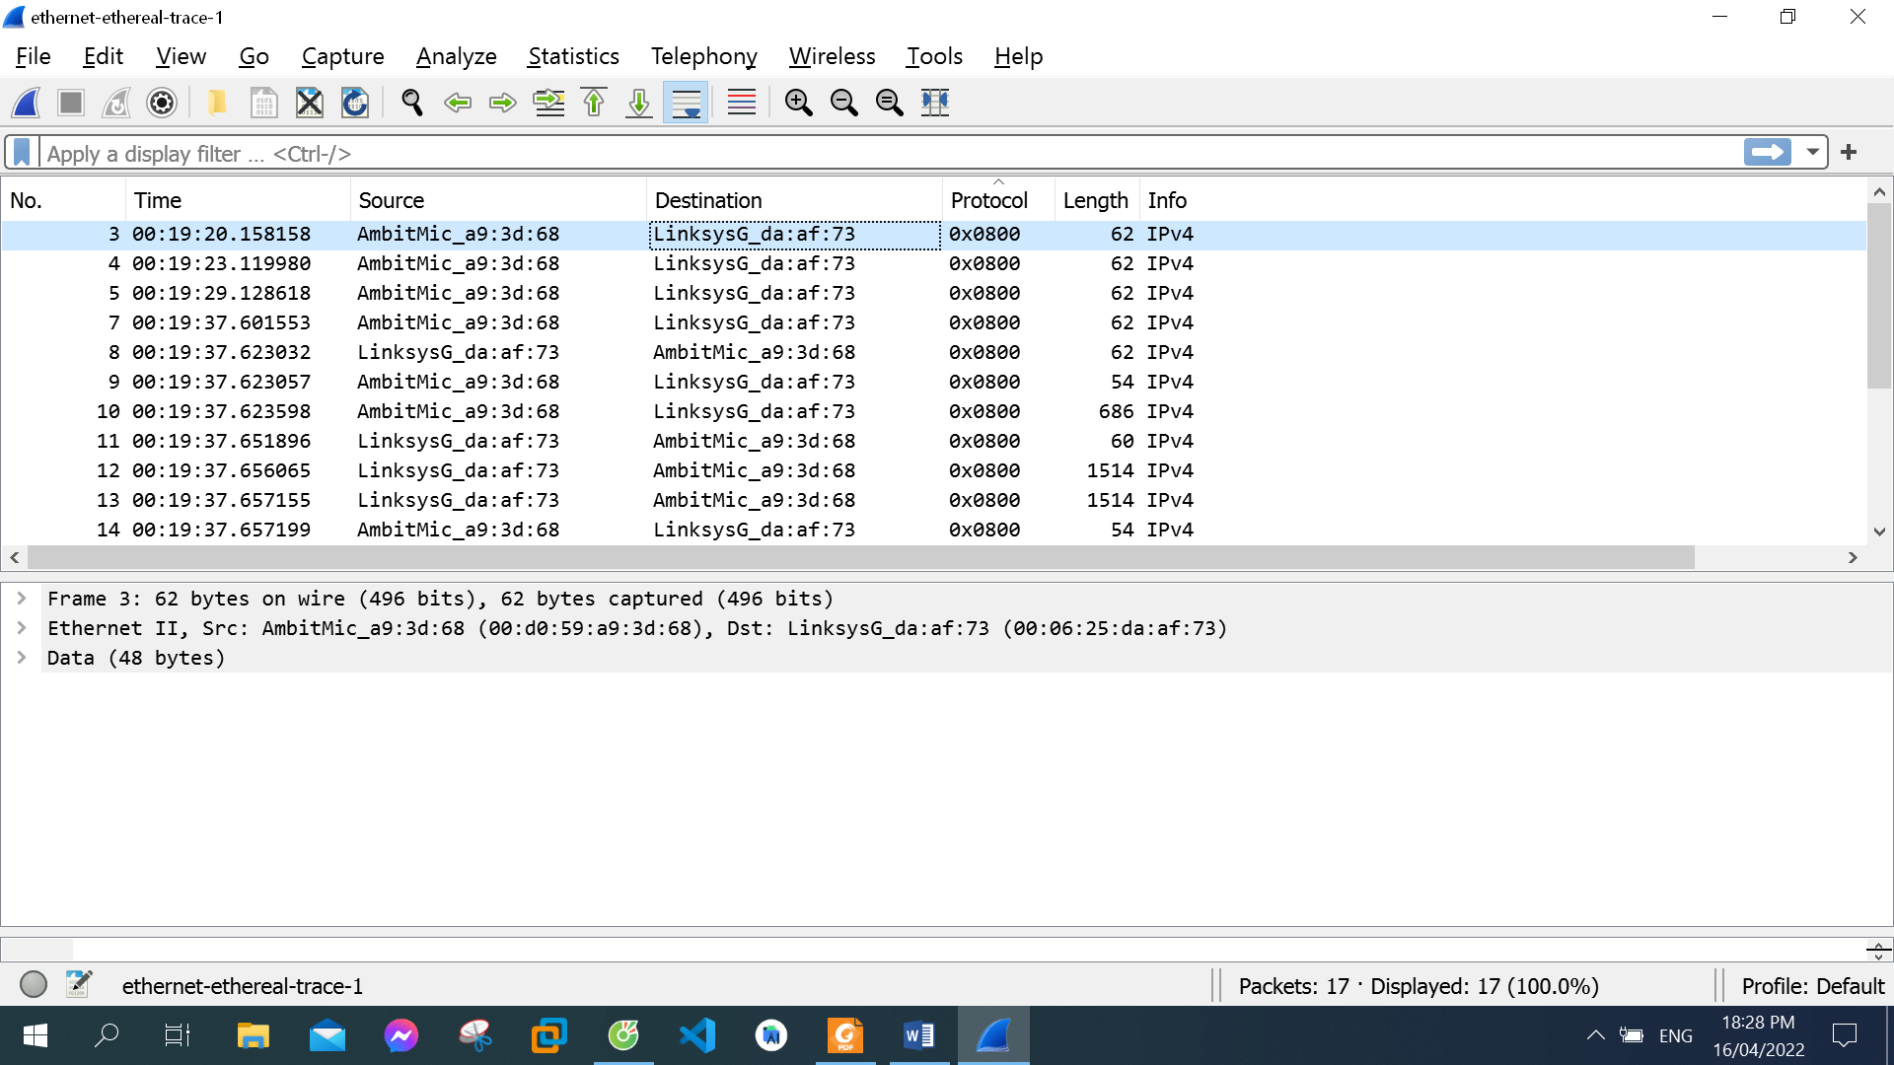

The 48-bit Ethernet address of my computer: 00:d0:59:a9:3d:68

1. What is the 48-bit destination address in the Ethernet frame? Is this the Ethernet address of gaia.cs.umass.edu? What device has this as its Ethernet address?

The 48-bit destination address in the Ethernet frame: 00:06:25:da:af:73

This is not the Ethernet address of gaia.cs.umass.edu

It is the address of my Linksys router

1. Give the hexadecimal value for the two-byte Frame type field. What upper layer protocol does this correspond to?

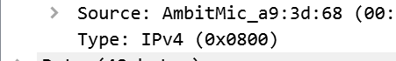

The hexadecimal value for the two-byte Frame type field: 0x0800

This corresponds to the IP protocol

1. How many bytes from the very start of the Ethernet frame does the ASCII “G” in “GET” appear in the Ethernet frame?

The ASCII “G” appears 52 bytes from the start of the Ethernet frame. There are 14 B Ethernet frame, and then 20 bytes of IP header followed by 20 bytes of TCP header before the HTTP data is encountered.

1. What is the value of the Ethernet source address? Is this the address of your computer, or of gaia.cs.umass.edu. What device has this as its Ethernet address?

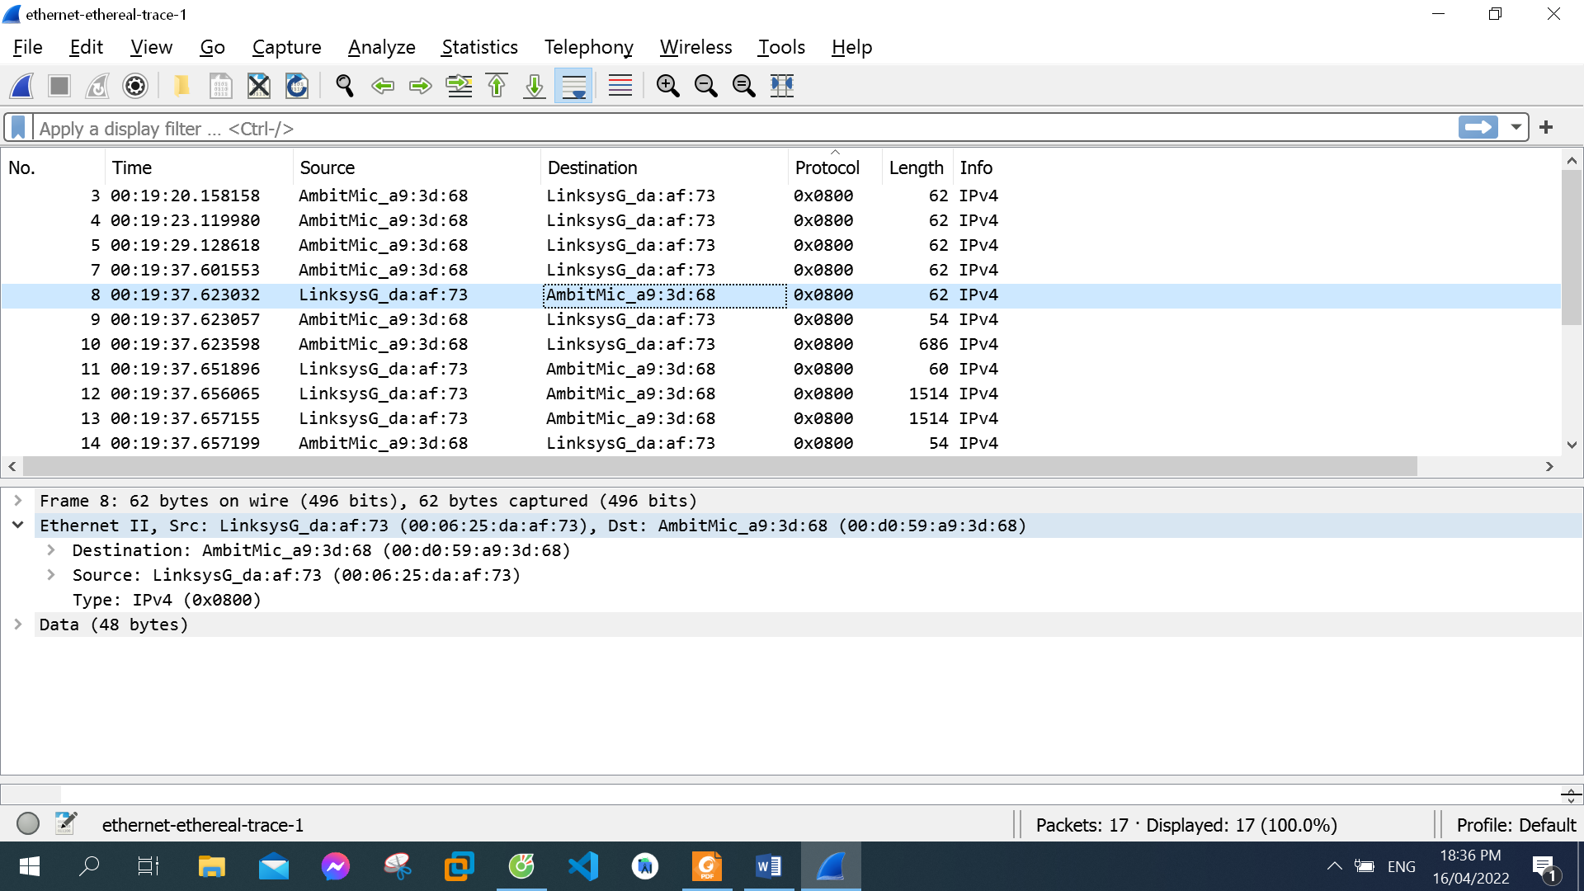

The value of the Ethernet source address: 00:06:25:da:af:73

This is neither the address of your computer nor of  the address gaia.cs.umass.edu

It is the address of my Linksys router

1. What is the destination address in the Ethernet frame? Is this the Ethernet address of your computer?

The destination address in the Ethernet frame:  00:d0:59:a9:3d:68

This is the Ethernet address of my computer

1. Give the hexadecimal value for the two-byte Frame type field. What upper layer protocol does this correspond to?

The hexadecimal value for the two-byte Frame type field: 0x0800

This corresponds to the IP protocol

8. How many bytes from the very start of the Ethernet frame does the ASCII “O” in “OK” (i.e., the HTTP response code) appear in the Ethernet frame?

The ASCII “O” appears 52 bytes from the start of the Ethernet frame. There are 14 bytes of Ethernet frame, and then 20 bytes of IP header followed by 20 bytes of TCP header before the HTTP data is encountered.

9. Write down the contents of your computer’s ARP cache. What is the meaning of each column value?

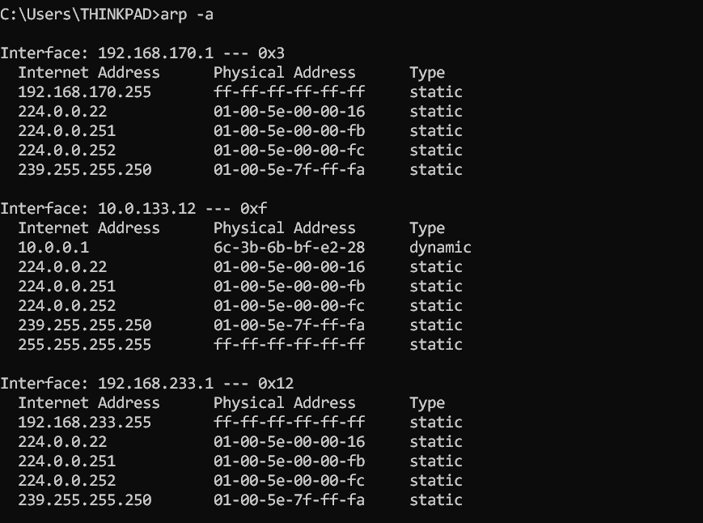

The Internet Address column contains the IP address, the Physical Address column contains the MAC address, and the type indicates the protocol type.

10. What are the hexadecimal values for the source and destination addresses in the Ethernet frame containing the ARP request message?

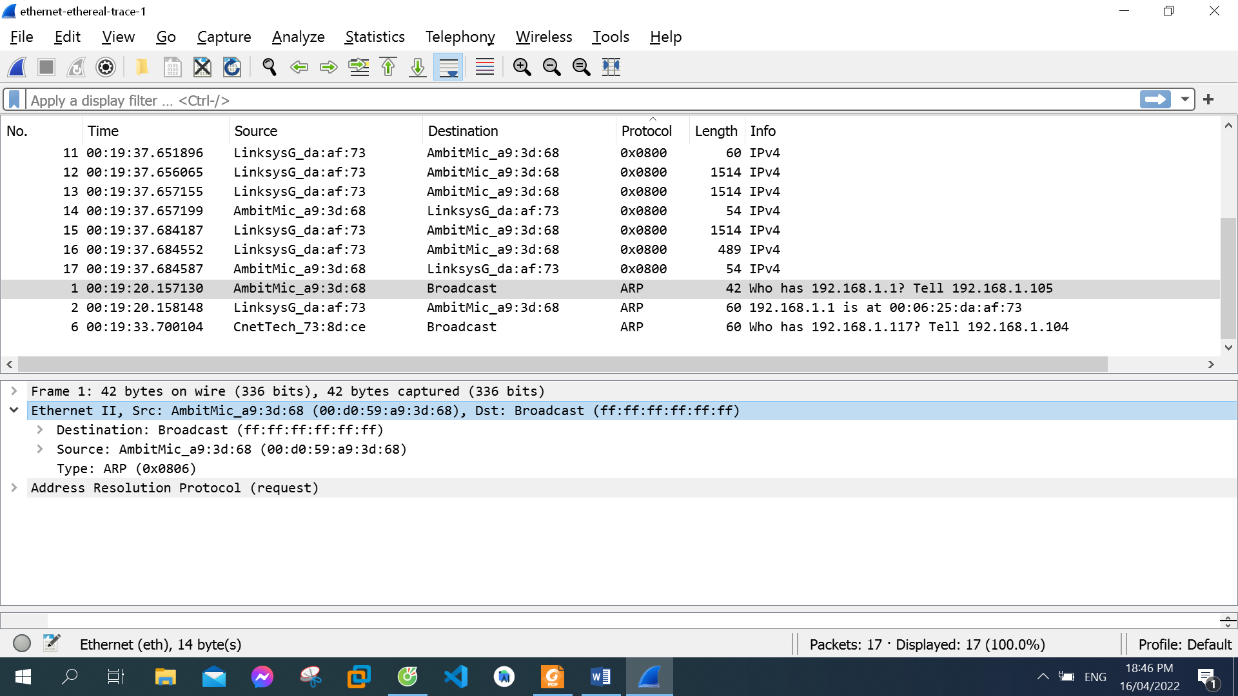

The hexadecimal values for the source addresses: 00:d0:59:a9:3d:68

The hexadecimal values for the destination addresses: ff:ff:ff:ff:ff:ff

11. Give the hexadecimal value for the two-byte Ethernet Frame type field. What upper layer protocol does this correspond to?



The hexadecimal value for the two-byte Ethernet Frame type field: 0x0806

This correspond to ARP protocol

1. Download the ARP specification from ftp://ftp.rfc-editor.org/in-notes/std/std37.txt. A readable, detailed discussion of ARP is also at http://www.erg.abdn.ac.uk/users/gorry/course/inet-pages/arp.html.

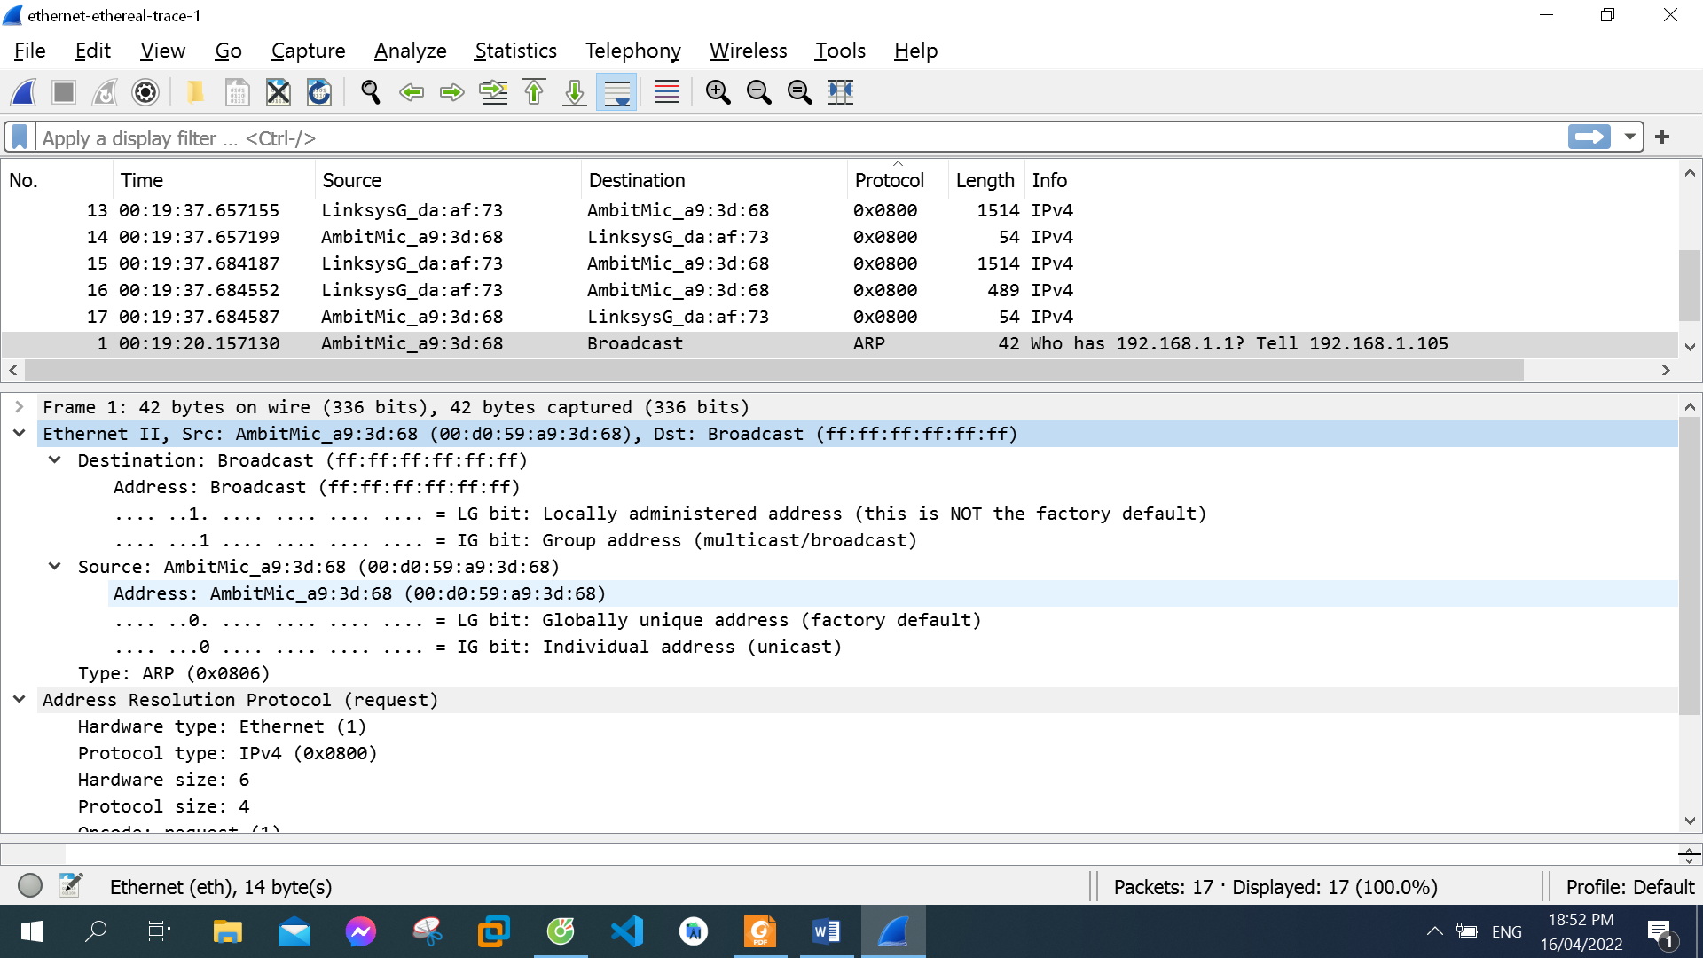

a) How many bytes from the very beginning of the Ethernet frame does the ARP opcode field begin?

The ARP opcode field begins 20 bytes from the very beginning of the Ethernet frame. There are 14 bytes from Ethernet frame, 2 bytes of Hardware type, 2 bytes of Protocol type, 1 byte of Hardware size, 1 byte of Protocol size.

b) What is the value of the opcode field within the ARP-payload part of the Ethernet frame in which an ARP request is made?



The value of the opcode field: 1

c) Does the ARP message contain the IP address of the sender?

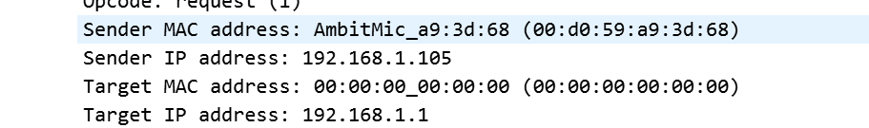

Yes. The IP address of the sender is 192.168.1.105

d) Where in the ARP request does the “question” appear – the Ethernet address of the machine whose corresponding IP address is being queried?

The field “Target MAC address” is set to 00:00:00:00:00:00 to question the machine whose corresponding IP address (192.168.1.1) is being queried.

1. Now find the ARP reply that was sent in response to the ARP request.

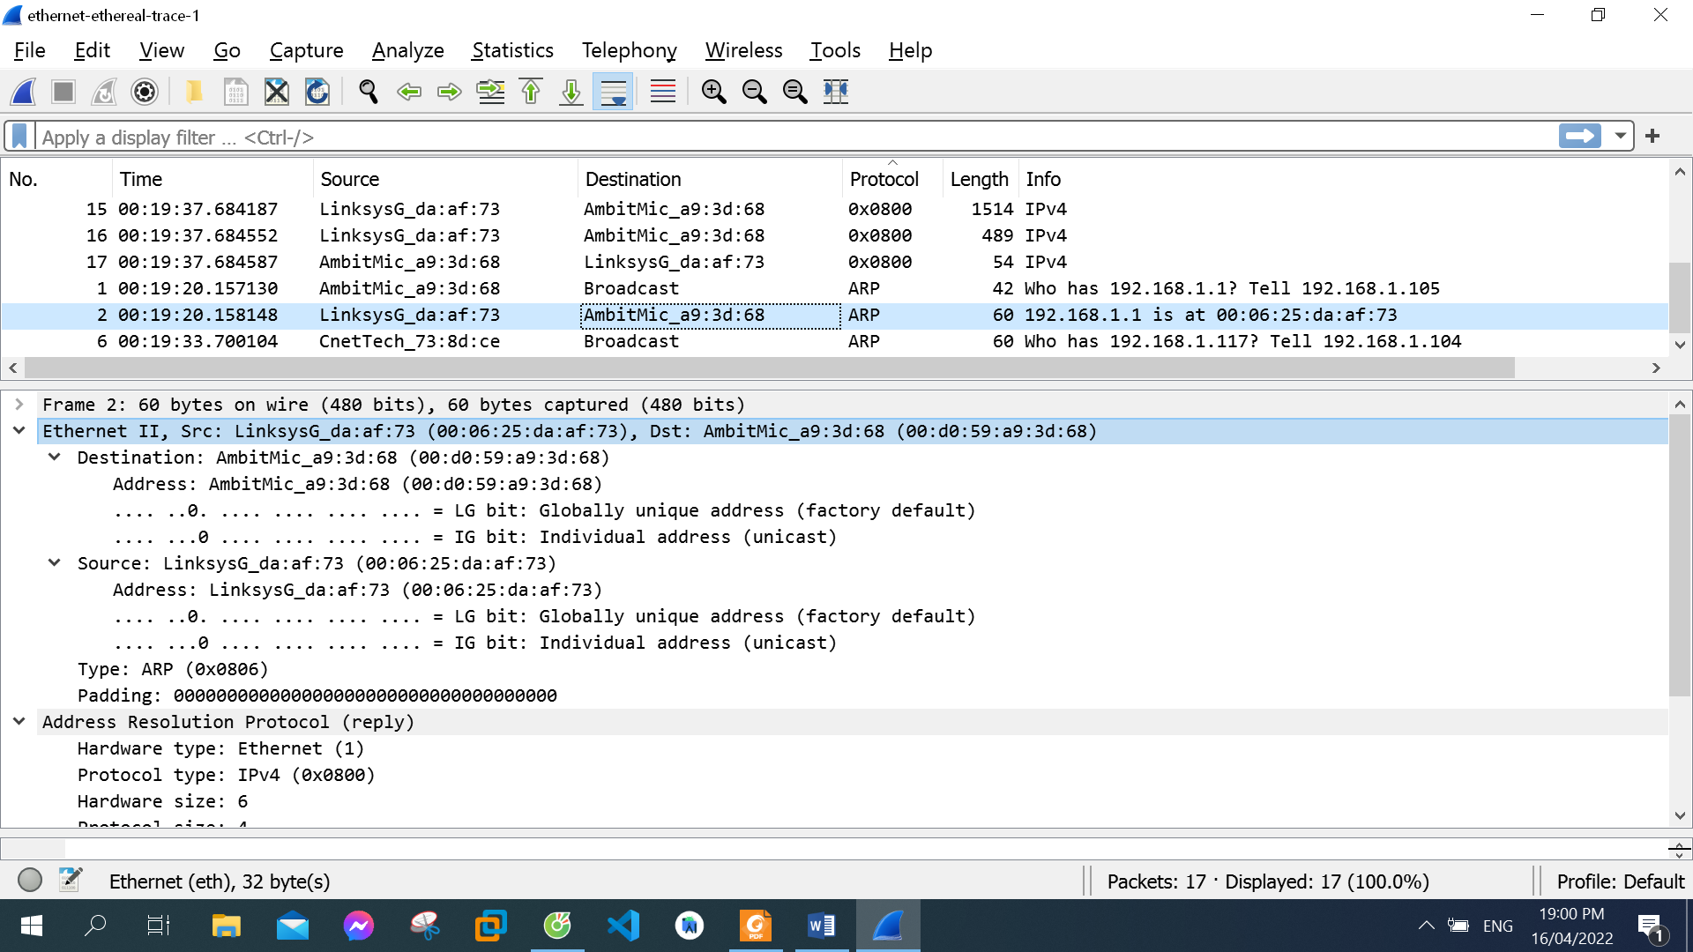

a) How many bytes from the very beginning of the Ethernet frame does the ARP opcode field begin?

The ARP opcode field begins 20 bytes from the very beginning of the Ethernet frame. There are 14 bytes from Ethernet frame, 2 bytes of Hardware type, 2 bytes of Protocol type, 1 byte of Hardware size, 1 byte of Protocol size

b) What is the value of the opcode field within the ARP-payload part of the Ethernet frame in which an ARP response is made?



The value of the opcode field: 2

c) Where in the ARP message does the “answer” to the earlier ARP request appear – the IP address of the machine having the Ethernet address whose corresponding IP address is being queried?

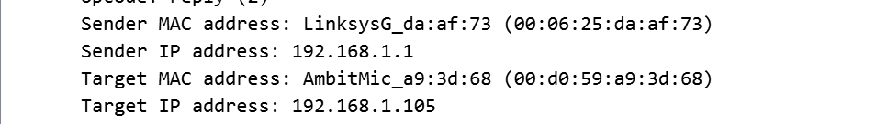

The answer to the earlier ARP request appears in the “Sender MAC address” field, which contains the Ethernet address 00:06:25:da:af:73 for the sender with IP address 192.168.1.1

14. What are the hexadecimal values for the source and destination addresses in the Ethernet frame containing the ARP reply message?

The hexadecimal values for the source address: 00:06:25:da:af:73

The hexadecimal values for the destination address: 00:d0:59:a9:3d:68

1. Open the ethernet-ethereal-trace-1 trace file in http://gaia.cs.umass.edu/wireshark-labs/wireshark-traces.zip. The first and second ARP packets in this trace correspond to an ARP request sent by the computer running Wireshark, and the ARP reply sent to the computer running Wireshark by the computer with the ARP-requested Ethernet address. But there is yet another computer on this network, as indicated by packet 6 – another ARP request. Why is there no ARP reply (sent in response to the ARP request in packet 6) in the packet trace?

There is no reply in this trace, because we are not at the machine that sent the request. The ARP request is broadcast, but the ARP reply is sent back directly to the sender’s Ethernet address.